# Summary

The foundation, TechForAll, solicits technology donations for students across the city. The devices are distributed by criteria determined by the foundation’s board of directors. The CompU database tracks the requests made by students to receive a device from the charity and the inventory of devices waiting to be distributed.

TechForAll’s mission is to bridge the digital divide and promote equal opportunities in education, TechForAll provides laptops and tablets to students in need, taking into account both their school district and disability.

To achieve their goal, TechForAll partnered closely with local schools and education authorities in the city. They established strong connections with school administrators, teachers, and counselors, who would identify students lacking access to technology due to financial constraints or disabilities.

Through their collaboration, TechForAll has devised a comprehensive process to evaluate each student's needs. They took into consideration the specific school district the student belonged to, ensuring that students from underserved areas were given priority. They also factored in disabilities or special needs, recognizing the importance of providing tailored support to those facing additional challenges.

TechForAll works diligently to gather resources, securing donations from individuals, local businesses, and corporate sponsors who share their vision.

# Goal

The goal of the database is to manage the requests, distribution, and inventory of gifted devices.

# Stakeholders

* Students
* Donors
* TechForAll Foundation

# Business Rules

* A student can request one or more devices
* A district can have more than one school
* A donor can donate more than one device to the inventory
* A district can only have one ranking
* A student can only have one disability ranking
* A district can only have one district rank
* A student can only have one grade rank

# Glossary

*Inventory:* The number of devices available for student requests.

*Students:* The requestors and recipients of devices.

*Requests:* Submitted by students to the foundation to be reviewed by CompU and then approved or denied based on the foundation's criteria.

*Device types:* The brand of laptops or tablets that are donated and distrusted by the foundation.

*Districts:* A special-purpose district that operates local public primary and secondary schools.

*Schools:* An institution for educating students.

*Donors:* The names of people who donated devices to TechForAll.

*District ranks:* Order of districts based on criteria defined by the charity’s board of directors. Ranked from 1-5, 1 beginning the ‘best.’

*Disability ranks:* Order of disabilities based on criteria defined by the charity’s board of directors. Ranked from 1-6. 6 is the most severe.

*Grade ranks*: The order of grades from 8th grade to 12th grade and their rank, 8th being 1 and 12th being 5.

*Order logs:* The transactions of devices approved for students.

# Data Questions

1. How can we notify a donor once their donated laptops have been given to a student?
2. How many students from each district have requested devices?
3. Who are our top donors?
4. How many students from each district have been approved for device allocation?
5. How many laptops and tablets are currently available in the inventory?
6. How will students be measured against GPA, disability, grade, and district?

# Conceptual Model

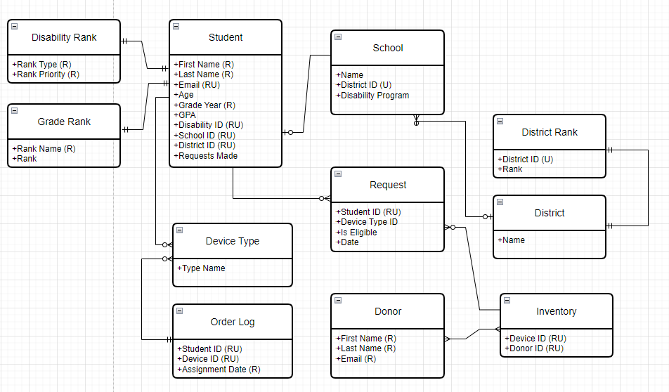

# Logical Model

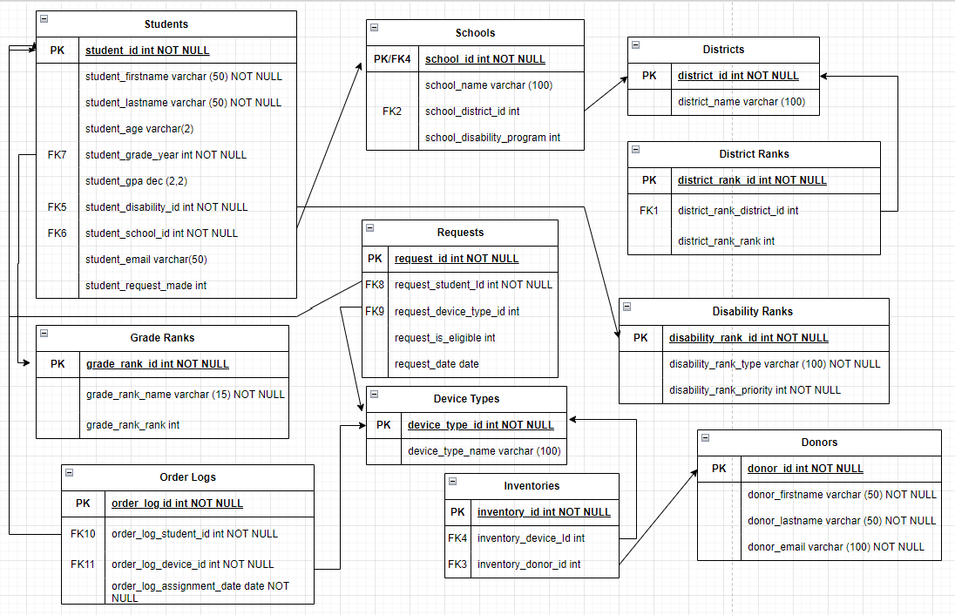

# Physical Database

-- down script

if not exists( select * from sys.databases where name = 'compu')

create database compu

GO

use compu

GO

--drop procedures

IF OBJECT_ID('EvaluateStudentRequests') IS NOT NULL

DROP PROCEDURE EvaluateStudentRequests

-- Drop the procedure if it already exists

IF OBJECT_ID('AssignDeviceToStudent', 'P') IS NOT NULL

DROP PROCEDURE AssignDeviceToStudent;

GO

-- drop views

IF OBJECT_ID('EvaluateStudentRequestView') IS NOT NULL

DROP VIEW EvaluateStudentRequestView

-- Drop tables in reverse order of creation

DROP TABLE IF EXISTS order_logs;

DROP TABLE IF EXISTS requests;

DROP TABLE IF EXISTS students;

DROP TABLE IF EXISTS grade_ranks;

DROP TABLE IF EXISTS inventorys;

DROP TABLE IF EXISTS device_types;

DROP TABLE IF EXISTS donors;

DROP TABLE IF EXISTS schools;

DROP TABLE if exists disability_ranks;

DROP table if exists district_ranks;

DROP TABLE IF EXISTS districts;

-- up script

-- Create table for districts

CREATE TABLE districts (

district_id INT NOT NULL identity,

district_name VARCHAR(100)

CONSTRAINT pk_districts_district_id primary key (district_id)

);

-- Insert records for districts

INSERT INTO districts (district_name) VALUES ( 'North School District');

INSERT INTO districts (district_name) VALUES ( 'West School District');

INSERT INTO districts (district_name) VALUES ('Town Square District');

INSERT INTO districts (district_name) VALUES ('Uptown District');

INSERT INTO districts (district_name) VALUES ('East Town District');

-- create table for district rank  
CREATE TABLE district_ranks (

district_rank_id INT NOT NULL identity,

district_rank_district_id INT,

district_rank_rank INT,

CONSTRAINT pk_district_ranks_district_rank_id PRIMARY KEY (district_rank_id),

FOREIGN KEY (district_rank_district_id) REFERENCES districts(district_id)

);

-- insert into district ranks

INSERT INTO district_ranks (district_rank_district_id, district_rank_rank) VALUES ( 1, 5);

INSERT INTO district_ranks (district_rank_district_id, district_rank_rank) VALUES (2, 3);

INSERT INTO district_ranks (district_rank_district_id, district_rank_rank) VALUES (3, 2);

INSERT INTO district_ranks (district_rank_district_id, district_rank_rank) VALUES ( 4, 4);

INSERT INTO district_ranks (district_rank_district_id, district_rank_rank) VALUES (5, 1);

-- create table for disability priority

create table disability_ranks(

disability_rank_id INT NOT NULL identity,

disability_rank_type VARCHAR(100) NOT NULL,

disability_rank_priority INT NOT NULL

CONSTRAINT pk_disability_ranks_disability_rank_id PRIMARY KEY (disability_rank_id)

);

-- Insert records into disability_ranks

INSERT INTO disability_ranks (disability_rank_type, disability_rank_priority) VALUES ('Multiple Disabilities', 5);

INSERT INTO disability_ranks (disability_rank_type, disability_rank_priority) VALUES ('Learning Disability', 4);

INSERT INTO disability_ranks (disability_rank_type, disability_rank_priority) VALUES ( 'Hearing Disability', 3);

INSERT INTO disability_ranks (disability_rank_type, disability_rank_priority) VALUES ( 'Visual Disability', 2);

INSERT INTO disability_ranks (disability_rank_type, disability_rank_priority) VALUES ( 'Physical Disability', 1);

INSERT INTO disability_ranks (disability_rank_type, disability_rank_priority) VALUES ( 'None', 0);

-- Create table for schools

CREATE TABLE schools (

school_id INT NOT NULL identity,

school_name VARCHAR(100),

school_district_id INT,

school_disabilities_program TINYINT DEFAULT 0,

CONSTRAINT pk_schools_school_id PRIMARY KEY (school_id),

CONSTRAINT fk_schools_district

FOREIGN KEY (school_district_id)

REFERENCES districts(district_id)

);

-- Inserting records for District 1

INSERT INTO schools (school_name, school_district_id, school_disabilities_program)

VALUES ('North Middle School', 1, 0);

INSERT INTO schools (school_name, school_district_id, school_disabilities_program)

VALUES ('North High School', 1, 1);

-- Inserting records for District 2

INSERT INTO schools (school_name, school_district_id, school_disabilities_program)

VALUES ('West High School', 2, 0);

INSERT INTO schools ( school_name, school_district_id, school_disabilities_program)

VALUES ('West Middle School', 2, 1);

INSERT INTO schools (school_name, school_district_id, school_disabilities_program)

VALUES ('Tom Barady High School', 2, 0);

-- Inserting records for District 3

INSERT INTO schools (school_name, school_district_id, school_disabilities_program)

VALUES ('Town Middle School', 3, 1);

INSERT INTO schools ( school_name, school_district_id, school_disabilities_program)

VALUES ('Town High School', 3, 0);

-- Inserting records for District 4

INSERT INTO schools ( school_name, school_district_id, school_disabilities_program)

VALUES ( 'Uptown Middle School', 4, 1);

INSERT INTO schools ( school_name, school_district_id, school_disabilities_program)

VALUES ( 'Uptown High School', 4, 0);

-- Inserting records for District 5

INSERT INTO schools ( school_name, school_district_id, school_disabilities_program)

VALUES ( 'East Middle School', 5, 0);

INSERT INTO schools ( school_name, school_district_id, school_disabilities_program)

VALUES ( 'East High School', 5, 1);

-- Create table for donors

CREATE TABLE donors (

donor_id INT NOT NULL identity,

donor_firstname VARCHAR(50) NOT NULL,

donor_lastname VARCHAR(50) NOT NULL,

donor_email VARCHAR(100) NOT NULL

CONSTRAINT pk_donors_donor_id PRIMARY KEY (donor_id)

);

-- Insert records for donors

INSERT INTO donors ( donor_firstname, donor_lastname, donor_email) VALUES ( 'John', 'Smith', '[john.smith@example.com](mailto:john.smith@example.com)');

INSERT INTO donors ( donor_firstname, donor_lastname, donor_email) VALUES ( 'Jane', 'Doe', '[jane.doe@example.com](mailto:jane.doe@example.com)');

INSERT INTO donors ( donor_firstname, donor_lastname, donor_email) VALUES ( 'Michael', 'Johnson', '[michael.johnson@example.com](mailto:michael.johnson@example.com)');

INSERT INTO donors ( donor_firstname, donor_lastname, donor_email) VALUES ( 'Emily', 'Brown', '[emily.brown@example.com](mailto:emily.brown@example.com)');

INSERT INTO donors ( donor_firstname, donor_lastname, donor_email) VALUES ( 'David', 'Miller', '[david.miller@example.com](mailto:david.miller@example.com)');

INSERT INTO donors ( donor_firstname, donor_lastname, donor_email) VALUES ( 'Olivia', 'Taylor', '[olivia.taylor@example.com](mailto:olivia.taylor@example.com)');

INSERT INTO donors ( donor_firstname, donor_lastname, donor_email) VALUES ( 'Daniel', 'Anderson', '[daniel.anderson@example.com](mailto:daniel.anderson@example.com)');

INSERT INTO donors ( donor_firstname, donor_lastname, donor_email) VALUES ( 'Sophia', 'Clark', '[sophia.clark@example.com](mailto:sophia.clark@example.com)');

INSERT INTO donors ( donor_firstname, donor_lastname, donor_email) VALUES ( 'Matthew', 'Walker', '[matthew.walker@example.com](mailto:matthew.walker@example.com)');

INSERT INTO donors ( donor_firstname, donor_lastname, donor_email) VALUES ( 'Ava', 'Harris', '[ava.harris@example.com](mailto:ava.harris@example.com)');

-- Create table for devices

CREATE TABLE device_types (

device_type_id INT NOT NULL identity,

device_type_name VARCHAR(100)

CONSTRAINT pk_device_types_device_type_id primary key (device_type_id)

);

-- Insert records into device_types

INSERT INTO device_types ( device_type_name) VALUES ('iPad');

INSERT INTO device_types (device_type_name) VALUES ('Samsung Tablet');

INSERT INTO device_types (device_type_name) VALUES ('Macbook');

INSERT INTO device_types (device_type_name) VALUES ('Chromebook');

-- Create table for inventory

CREATE TABLE inventorys (

inventory_id INT NOT NULL identity,

inventory_device_id INT,

inventory_donor_id INT,

CONSTRAINT pk_inventorys_inventory_id primary key (inventory_id),

CONSTRAINT fk_inventorys_device_id

FOREIGN KEY (inventory_device_id)

REFERENCES device_types(device_type_id),

constraint fk_inventorys_donor_id

FOREIGN KEY (inventory_donor_id)

REFERENCES donors(donor_id)

);

-- Insert records into inventorys

-- Inserting records for inventory_id 1-10

INSERT INTO inventorys ( inventory_device_id, inventory_donor_id)

VALUES ( 1, 1);

INSERT INTO inventorys ( inventory_device_id, inventory_donor_id)

VALUES ( 2, 2);

INSERT INTO inventorys ( inventory_device_id, inventory_donor_id)

VALUES ( 3, 3);

INSERT INTO inventorys ( inventory_device_id, inventory_donor_id)

VALUES ( 4, 4);

INSERT INTO inventorys ( inventory_device_id, inventory_donor_id)

VALUES ( 3, 5);

INSERT INTO inventorys ( inventory_device_id, inventory_donor_id)

VALUES ( 1, 6);

INSERT INTO inventorys ( inventory_device_id, inventory_donor_id)

VALUES ( 1, 7);

INSERT INTO inventorys ( inventory_device_id, inventory_donor_id)

VALUES ( 3, 8);

INSERT INTO inventorys ( inventory_device_id, inventory_donor_id)

VALUES ( 4, 9);

INSERT INTO inventorys ( inventory_device_id, inventory_donor_id)

VALUES ( 3, 10);

-- Inserting records for inventory_id 11-20

INSERT INTO inventorys ( inventory_device_id, inventory_donor_id)

VALUES ( 1, 1);

INSERT INTO inventorys ( inventory_device_id, inventory_donor_id)

VALUES ( 2, 1);

INSERT INTO inventorys ( inventory_device_id, inventory_donor_id)

VALUES ( 3, 1);

INSERT INTO inventorys ( inventory_device_id, inventory_donor_id)

VALUES ( 4, 4);

INSERT INTO inventorys ( inventory_device_id, inventory_donor_id)

VALUES ( 1, 6);

INSERT INTO inventorys ( inventory_device_id, inventory_donor_id)

VALUES ( 1, 6);

INSERT INTO inventorys ( inventory_device_id, inventory_donor_id)

VALUES ( 2, 7);

INSERT INTO inventorys ( inventory_device_id, inventory_donor_id)

VALUES ( 3, 8);

INSERT INTO inventorys ( inventory_device_id, inventory_donor_id)

VALUES ( 4, 6);

INSERT INTO inventorys ( inventory_device_id, inventory_donor_id)

VALUES ( 2, 10);

-- Inserting records for inventory_id 21-30

INSERT INTO inventorys ( inventory_device_id, inventory_donor_id)

VALUES ( 1, 1);

INSERT INTO inventorys ( inventory_device_id, inventory_donor_id)

VALUES ( 2, 2);

INSERT INTO inventorys ( inventory_device_id, inventory_donor_id)

VALUES ( 3, 7);

INSERT INTO inventorys ( inventory_device_id, inventory_donor_id)

VALUES ( 4, 7);

INSERT INTO inventorys ( inventory_device_id, inventory_donor_id)

VALUES ( 4, 5);

INSERT INTO inventorys ( inventory_device_id, inventory_donor_id)

VALUES ( 1, 1);

INSERT INTO inventorys ( inventory_device_id, inventory_donor_id)

VALUES ( 2, 1);

INSERT INTO inventorys ( inventory_device_id, inventory_donor_id)

VALUES ( 3, 8);

INSERT INTO inventorys ( inventory_device_id, inventory_donor_id)

VALUES ( 4, 10);

INSERT INTO inventorys ( inventory_device_id, inventory_donor_id)

VALUES ( 3, 10);

--create table for grade_ranks

create table grade_ranks(

grade_rank_id INT NOT NULL ,

grade_rank_name VARCHAR(15) NOT NULL,

grade_rank_rank INT NULL

CONSTRAINT pk_grade_ranks_grade_rank_id PRIMARY KEY (grade_rank_id)

);

--insert values for grade_ranks

INSERT INTO grade_ranks (grade_rank_id, grade_rank_name, grade_rank_rank)

VALUES

(8, '8th Grade', 1),

(9, '9th Grade', 2),

(10, '10th Grade', 3),

(11, '11th Grade', 4),

(12, '12th Grade', 5);

-- Create table for students

CREATE TABLE students (

student_id INT NOT NULL identity,

student_firstname VARCHAR(50) NOT NULL,

student_lastname VARCHAR(50) NOT NULL,

student_email VARCHAR(50) NOT NULL UNIQUE,

student_age INT NULL,

student_grade_year INT NOT NULL,

student_gpa DECIMAL (3,2) NULL,

student_disability_id INT not null,

student_school_id INT NOT NULL,

student_requests_made INT NULL

CONSTRAINT pk_students_student_id PRIMARY key (student_id),

CONSTRAINT fk_students_disability_id

FOREIGN KEY (student_disability_id)

REFERENCES disability_ranks(disability_rank_id),

CONSTRAINT fk_students_school

FOREIGN KEY (student_school_id)

REFERENCES schools(school_id),

constraint fk_students_student_grade_year

FOREIGN key (student_grade_year)

REFERENCES grade_ranks(grade_rank_id)

);

ALTER TABLE students

ALTER COLUMN student_gpa DECIMAL(3, 2);

ALTER TABLE students

DROP COLUMN student_requests_made;

-- Insert records for students

INSERT INTO students ( student_firstname, student_lastname, student_email, student_age, student_grade_year, student_gpa, student_disability_id, student_school_id)

VALUES

('John', 'Smith', '[john.smith@example.edu](mailto:john.smith@example.edu)', 16, 10, 3.75, 1, 1),

('Emily', 'Johnson', '[emily.johnson@funnyemail.edu](mailto:emily.johnson@funnyemail.edu)', 15, 9, 3.88, 6, 1),

( 'Michael', 'Williams', '[michael.williams@lolmail.edu](mailto:michael.williams@lolmail.edu)', 17, 11, 3.60, 4, 1),

( 'Olivia', 'Brown', '[olivia.brown@hilariousmail.edu](mailto:olivia.brown@hilariousmail.edu)', 14, 8, 3.92, 5, 2),

( 'James', 'Jones', '[james.jones@crazymail.edu](mailto:james.jones@crazymail.edu)', 15, 9, 2.80, 1, 2),

( 'Sophia', 'Davis', '[sophia.davis@randommail.edu](mailto:sophia.davis@randommail.edu)', 16, 10, 3.65, 2, 3),

( 'Daniel', 'Miller', '[daniel.miller@sillymail.edu](mailto:daniel.miller@sillymail.edu)', 15, 9, 3.95, 1, 4),

( 'Ava', 'Wilson', '[ava.wilson@weirdmail.edu](mailto:ava.wilson@weirdmail.edu)', 17, 11, 3.72, 5, 4),

( 'Liam', 'Taylor', '[liam.taylor@goofymail.edu](mailto:liam.taylor@goofymail.edu)', 14, 8, 2.81, 1, 5),

( 'Emma', 'Anderson', '[emma.anderson@oddmail.edu](mailto:emma.anderson@oddmail.edu)', 15, 9, 3.88, 2, 5),

( 'Benjamin', 'Martinez', '[benjamin.martinez@crazymail.edu](mailto:benjamin.martinez@crazymail.edu)', 16, 10, 3.70, 4, 6),

( 'Mia', 'Hernandez', '[mia.hernandez@funnyemail.edu](mailto:mia.hernandez@funnyemail.edu)', 14, 8, 3.91, 5, 6),

( 'Elijah', 'Lopez', '[elijah.lopez@lolmail.edu](mailto:elijah.lopez@lolmail.edu)', 15, 9, 2.76, 5, 6),

( 'Charlotte', 'Garcia', '[charlotte.garcia@hilariousmail.edu](mailto:charlotte.garcia@hilariousmail.edu)', 17, 11, 3.84, 2, 7),

( 'William', 'Smith', '[william.smith@crazymail.edu](mailto:william.smith@crazymail.edu)', 14, 8, 3.90, 6, 7),

( 'Amelia', 'Johnson', '[amelia.johnson@randommail.edu](mailto:amelia.johnson@randommail.edu)', 15, 9, 3.78, 2, 7),

( 'Alexander', 'Williams', '[alexander.williams@weirdmail.edu](mailto:alexander.williams@weirdmail.edu)', 16, 10, 3.68, 1, 8),

( 'Harper', 'Brown', '[harper.brown@hilariousmail.edu](mailto:harper.brown@hilariousmail.edu)', 14, 8, 3.89, 2, 8),

( 'Daniel', 'Jones', '[daniel.jones@crazymail.edu](mailto:daniel.jones@crazymail.edu)', 15, 9, 2.83, 6, 9),

('Evelyn', 'Davis', '[evelyn.davis@randommail.edu](mailto:evelyn.davis@randommail.edu)', 17, 11, 3.79, 2, 9),

( 'Jacob', 'Miller', '[jacob.miller@sillymail.edu](mailto:jacob.miller@sillymail.edu)', 15, 9, 3.82, 6, 9),

( 'Abigail', 'Wilson', '[abigail.wilson@weirdmail.edu](mailto:abigail.wilson@weirdmail.edu)', 16, 12, 2.73, 3, 10),

( 'Noah', 'Taylor', '[noah.taylor@goofymail.edu](mailto:noah.taylor@goofymail.edu)', 14, 8, 3.93, 6, 10),

( 'Sofia', 'Anderson', '[sofia.anderson@oddmail.edu](mailto:sofia.anderson@oddmail.edu)', 15, 9, 3.87, 2, 11),

( 'Logan', 'Martinez', '[logan.martinez@crazymail.edu](mailto:logan.martinez@crazymail.edu)', 17, 12, 2.77, 5, 11);

-- Create table for requests

CREATE TABLE requests (

request_id INT NOT NULL identity,

request_student_id INT,

request_device_type_id INT,

request_date DATE,

request_is_eligible TINYINT,

CONSTRAINT pk_requests_request_id PRIMARY key (request_id),

CONSTRAINT fk_requests_student

FOREIGN KEY (request_student_id)

REFERENCES students(student_id),

CONSTRAINT fk_requests_device

FOREIGN KEY (request_device_type_id)

REFERENCES device_types(device_type_id)

);

-- insert into requests

INSERT INTO requests (request_student_id, request_device_type_id, request_date, request_is_eligible)

VALUES

(1, 1, '2022-08-15',1),

(2, 2, '2022-07-04',0),

(3, 3, '2022-08-17',1),

(4, 4, '2022-09-19',1),

(5, 1, '2022-10-25', 0),

(6, 2, '2022-08-15',1),

(7, 2, '2022-08-20',0),

(8, 4, '2022-07-12',1);

create table order_logs (

order_log_id int NOT NULL identity,

order_log_student_id int NOT NULL,

order_log_device_id int NOT NULL,

order_log_assignment_date DATE NOT NULL,

CONSTRAINT pk_order_logs_order_log_id primary key (order_log_id),

CONSTRAINT fk_order_logs_student_id

FOREIGN key (order_log_student_id)

REFERENCES students(student_id),

CONSTRAINT fk_order_logs_order_log_device_id

FOREIGN key (order_log_device_id)

REFERENCES device_types(device_type_id)

)

-- now lets create a procedure to insert a new request and see if a student who is making a request is already in the database

use compu

GO

DROP PROCEDURE IF EXISTS dbo.InsertRequest;

GO

CREATE PROCEDURE dbo.InsertRequest

@firstName varchar(50),

@lastName varchar(50),

@email varchar(50),

@grade INT,

@gpa DECIMAL(3,2),

@disability varchar(100),

@school varchar(100),

@request_date DATE,

@deviceType VARCHAR(100)

AS

BEGIN

-- checking whether or not the student is a new student in the database

If Not Exists (Select 1 from students where student_email = @email)

BEGIN

--inserting new student

Insert into students(student_firstname, student_lastname, student_email, student_grade_year, student_gpa, student_disability_id, student_school_id)

Values (@firstName, @lastName, @email, @grade, @gpa, (select disability_rank_id from disability_ranks where disability_rank_type = @disability),

(select school_id from schools where school_name = @school)

);

END

--insert the request

INSERT INTO requests (request_student_id, request_device_type_id, request_date)

VALUES ((select student_id from students where student_email=@email), (select device_type_id from device_types where device_type_name =@deviceType), @request_date );

END

GO

declare @studentfirstname varchar(50), @studentlastname varchar(50), @email varchar(50), @grade INT, @gpa decimal (3,2), @disability varchar(100), @school varchar(100),

@request_date DATE, @devicetype VARCHAR(100)

SET @studentfirstname = 'Wade'

set @studentlastname = 'Wilson'

set @email = '[wadewilly@deadpool.edu](mailto:wadewilly@deadpool.edu)'

set @grade = 10

set @gpa = 3.82

set @disability = 'Learning Disability'

set @school = 'North High School'

set @request_date = '2022-09-10'

set @devicetype = 'Macbook'

EXEC dbo.InsertRequest @studentfirstname, @studentlastname, @email, @grade, @gpa, @disability, @school, @request_date, @devicetype

select * from requests

select * from students  
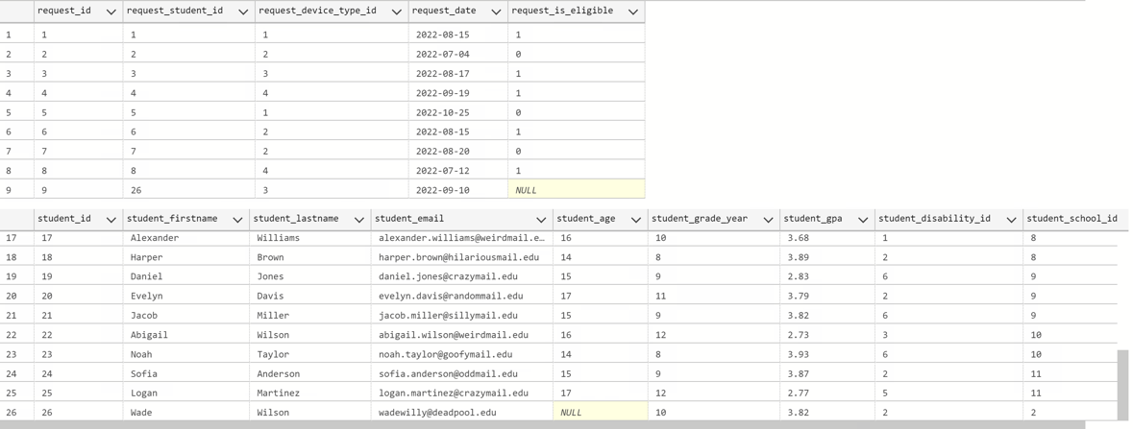

-- we can see that a student has been added to the table, students, and a new request as well

-- now lets create a view for us to decide if they get a laptop, enter in a student to get a composite score back and see how high that composite score is, anything in the 3 or above is a great score.

GO

CREATE VIEW EvaluateStudentRequestView

AS

SELECT

s.student_id,

s.student_firstname + ' ' + s.student_lastname as Student_name,

s.student_gpa,

dr.disability_rank_type,

g.grade_rank_name,

r.request_date,

sc.school_name,

dis.district_name,

(

(s.student_gpa / 4.0) * 0.3 +

dr.disability_rank_priority * 0.3 +

g.grade_rank_rank * 0.2 + 1`

disr.district_rank_rank * 0.2

) AS composite_score,

RANK() OVER (ORDER BY

(s.student_gpa / 4.0) * 0.3 +

dr.disability_rank_priority * 0.3 +

g.grade_rank_rank * 0.2 +

disr.district_rank_rank * 0.2 DESC

) AS student_rank

FROM

requests r

left join students as s on r.request_student_id = s.student_id

left join disability_ranks as dr on s.student_disability_id = dr.disability_rank_id

left join schools as sc on s.student_school_id = sc.school_id

left join grade_ranks as g on g.grade_rank_id = s.student_grade_year

left join districts as dis on sc.school_district_id = dis.district_id

left join district_ranks as disr on disr.district_rank_district_id = dis.district_id

GO

select * from EvaluateStudentRequestView

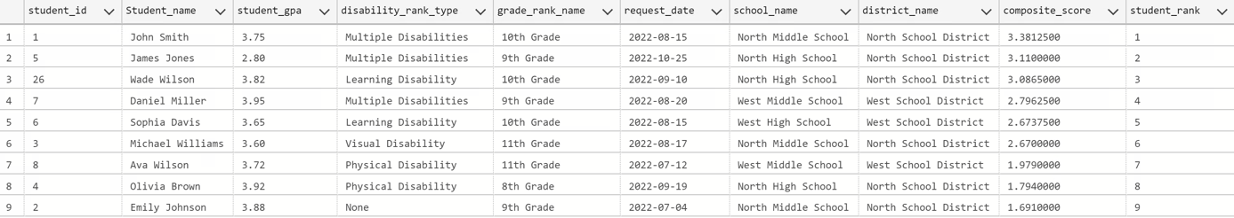

-- Create Procedure for AssignDevicetoStudent if they are evaluated and accepted

GO

CREATE PROCEDURE AssignDeviceToStudent (@student_email VARCHAR(50), @device_type_name VARCHAR(100))

AS

BEGIN

-- Check if the student exists in the 'students' table

IF NOT EXISTS (SELECT 1 FROM students WHERE student_email = @student_email)

BEGIN

RAISERROR ('Student does not exist.',12,1)

RETURN

END

-- check if requested device type is available in inventory

IF NOT Exists (Select 1 from inventorys left join device_types on device_type_id = inventory_device_id where device_type_name = @device_type_name)

BEGIN

RAISERROR ( 'Device type is not available inventory.', 16, 1)

RETURN

END

-- Check if there is an available device of the requested type

DECLARE @deviceId INT

SELECT TOP 1 @deviceId = inventory_device_id

FROM inventorys left join device_types on device_type_id = inventory_device_id

WHERE device_type_name = @device_type_name

IF @deviceId IS NULL

BEGIN

RAISERROR('No available device of the requested type.', 12, 1)

RETURN

END

-- Assign the device to the student

delete from inventorys

WHERE inventory_device_id = @deviceId

-- Delete the request

DELETE FROM requests

WHERE request_student_id = (SELECT student_id FROM students WHERE student_email = @student_Email)

AND request_device_type_id = (SELECT device_type_id FROM device_types WHERE device_type_name = @device_type_name)

-- Store the assignment information in a separate table (e.g., assignments_history)

INSERT INTO order_logs (order_log_student_id, order_log_device_id, order_log_assignment_date)

VALUES ((SELECT student_id FROM students WHERE student_email = @student_Email), @deviceId, GETDATE())

-- Return success message

SELECT 'Device assigned successfully.' AS Message

END

-- Test Procedure AssignDevicetoStudent

GO

declare @student_email VARCHAR(50) , @device_type_name Varchar(50)

set @student_email = '[emily.johnson@funnyemail.edu](mailto:emily.johnson@funnyemail.edu)'

set @device_type_name = 'Macbook'

EXEC AssignDeviceToStudent @student_email , @device_type_name

select * from order_logs

-- Data Question 1: How can we notify a donor once their donated laptops have been given to a student?

IF OBJECT_ID('NotifyDonor', 'P') IS NOT NULL

DROP PROCEDURE NotifyDonor;

GO

CREATE PROCEDURE NotifyDonor (@donor_id INT)

AS

BEGIN

-- Check if the donor exists in the 'donors' table

IF EXISTS (SELECT 1 FROM donors WHERE donor_id = @donor_id)

BEGIN

-- Get the donor's email

DECLARE @donor_email VARCHAR(100);

SELECT @donor_email = donor_email FROM donors WHERE donor_id = @donor_id;

-- Get the student's full name

DECLARE @student_fullname VARCHAR(100);

SELECT @student_fullname = CONCAT(student_firstname, ' ', student_lastname)

FROM students WHERE student_id = @student_fullname;

-- Compose the email message

DECLARE @message VARCHAR(MAX);

SET @message = CONCAT(

'Dear Donor,',

CHAR(50), CHAR(10), CHAR(13), CHAR(10),

'We want to inform you that your donated device has been assigned to a student.',

CHAR(50), CHAR(10), CHAR(13), CHAR(10),

'Student Name: ', @student_fullname,

CHAR(50), CHAR(10), CHAR(13), CHAR(10),

'Thank you for your generous donation!',

CHAR(50), CHAR(10), CHAR(13), CHAR(10),

'Best regards,',

CHAR(50), CHAR(10),

'TechForAll'

);

-- Send the email to the donor

EXEC send_dbmail

@recipients = @donor_email,

@subject = 'Device Donation Notification',

@body = @message;

PRINT 'Donor notification sent successfully.';

END

ELSE

BEGIN

PRINT 'Donor does not exist.';

END

END

-- Data Question 2: How many students from each district have requested a device?

SELECT d.district_name , COUNT(r.request_student_id) AS request_count

FROM districts d

LEFT JOIN schools s ON d.district_id = s.school_district_id

LEFT JOIN students st ON s.school_id = st.student_school_id

LEFT JOIN requests r ON st.student_id = r.request_student_id

GROUP BY d.district_name;

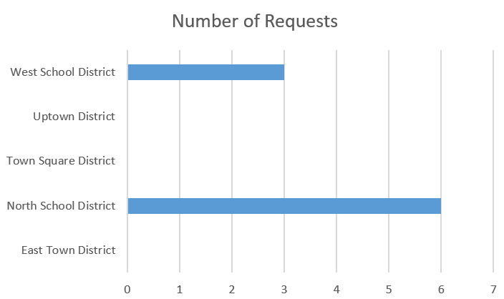

-- Data Question 3: Who are our top donors?

select d.donor_firstname + ' ' + d.donor_lastname as donor_name, COUNT(i.inventory_donor_id) as number_of_devices

from donors d

left join inventorys as i on d.donor_id = i.inventory_donor_id

group by d.donor_lastname, d.donor_firstname

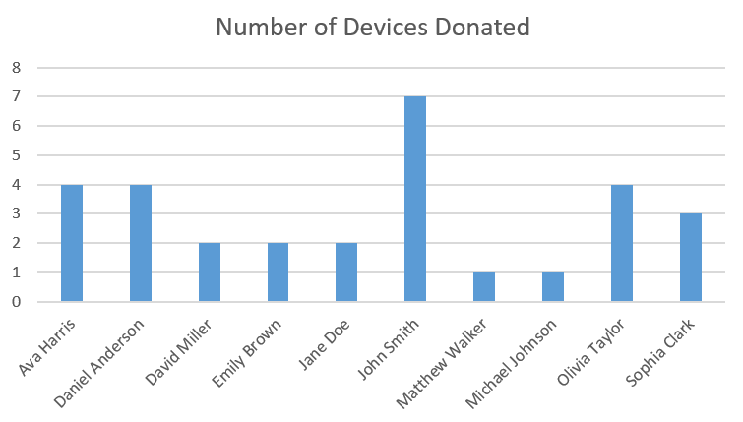

--Data Question 4: How many students from each district have been approved for device allocation?

select d.district_name, count(s.student_id) as Number_of_Approved_Students

from students s

right join order_logs as o on o.order_log_student_id = s.student_id

left join schools as sc on s.student_school_id = sc.school_id

right join districts as d on d.district_id = sc.school_district_id

Group by d.district_name

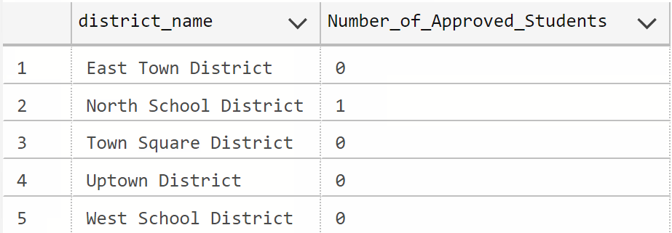

--Data Question 5: How many laptops and tablets are currently available in the inventory?

select * from inventorys

SELECT

SUM(CASE WHEN inventory_device_id IN (1,2) THEN 1 ELSE 0 END) AS tablet_count,

SUM(CASE WHEN inventory_device_id IN (3,4) THEN 1 ELSE 0 END) AS laptop_count

FROM

inventorys

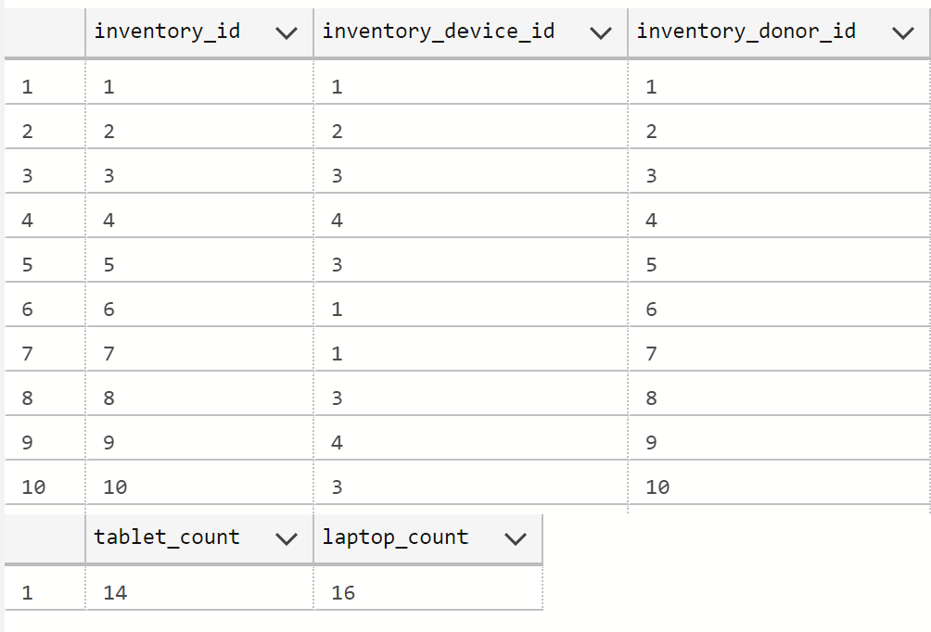

-- Data Question 6: How will students be measured against GPA, disability, grade, and district?

SELECT

s.student_id,

s.student_firstname + ' ' + s.student_lastname as Student_name,

s.student_gpa,

dr.disability_rank_type,

g.grade_rank_name,

r.request_date,

sc.school_name,

dis.district_name,

(

(s.student_gpa / 4.0) * 0.3 +

dr.disability_rank_priority * 0.3 +

g.grade_rank_rank * 0.2 +

disr.district_rank_rank * 0.2

) AS composite_score,

RANK() OVER (ORDER BY

(s.student_gpa / 4.0) * 0.3 +

dr.disability_rank_priority * 0.3 +

g.grade_rank_rank * 0.2 +

disr.district_rank_rank * 0.2 DESC

) AS student_rank

FROM

requests r

left join students as s on r.request_student_id = s.student_id

left join disability_ranks as dr on s.student_disability_id = dr.disability_rank_id

left join schools as sc on s.student_school_id = sc.school_id

left join grade_ranks as g on g.grade_rank_id = s.student_grade_year

left join districts as dis on sc.school_district_id = dis.district_id

left join district_ranks as disr on disr.district_rank_district_id = dis.district_id

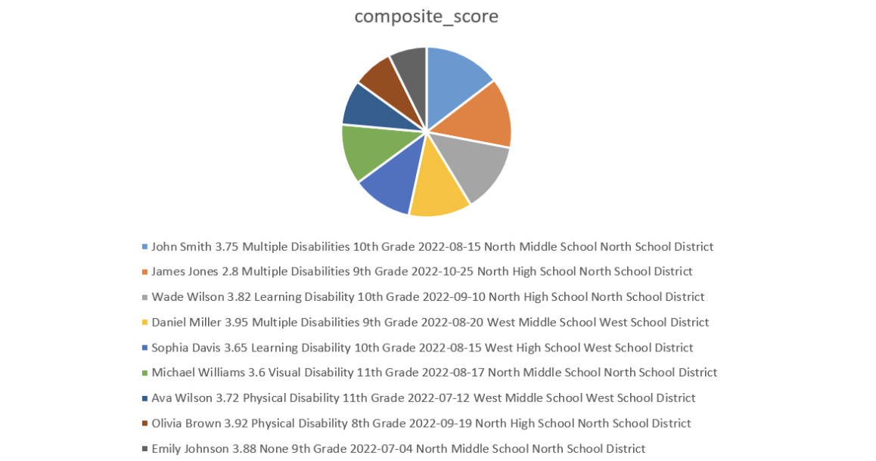

# Application Mock-ups

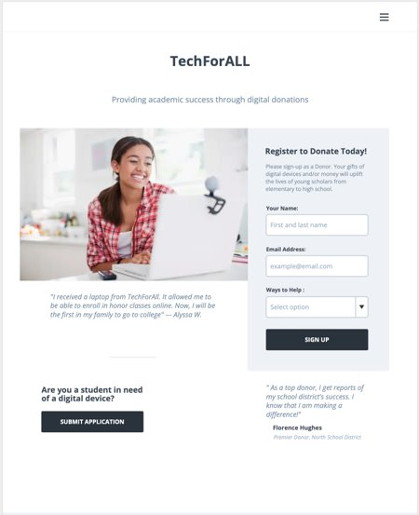

The TechForAll interface acts as a bridge between the donors and the students that need digital equipment.

Once a donor signs up with their name and email, their profile is created. From their profile, donors are now able to make donations, see their contribution status, as well as observe how well TechForAll is performing.

Students are also able to submit applications for equipment.

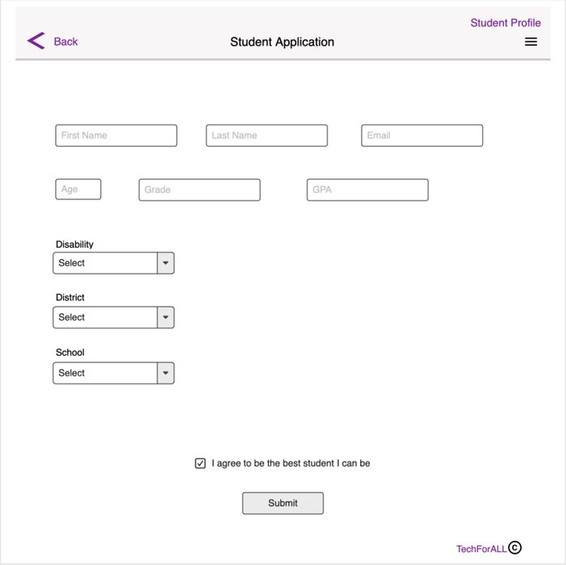

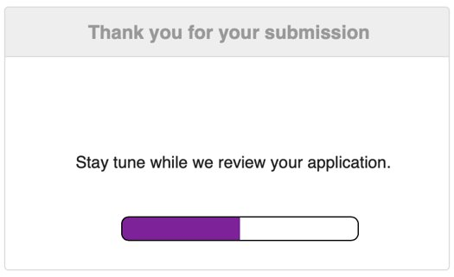

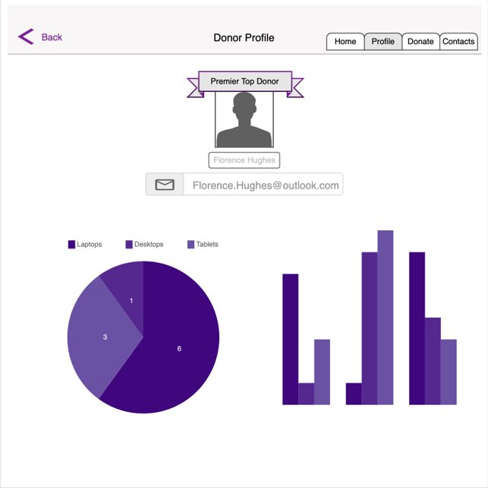

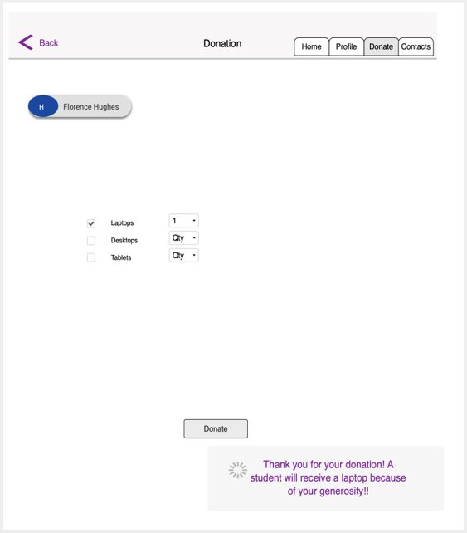

# Reflection

Throughout this project, we learned the importance of well-kept data and an organized database. The use of the logical model really helped us in shaping the database and making sure we had all the components. If we had to do it again, we think more input data would have been very helpful since it would have made our data questions more useful. Right now, there isn’t enough data to make any large statements on which students and from what district are benefiting the most from our charity. None of us were too familiar with Microsoft Access and it proved very difficult to find proper models to showcase what we have done. In the end we think we all learned a valuable amount of SQL and better understand the use of procedures, views, and triggers.

# Summary

Making this database taught us how to use SQL to better understand the use of databases. The charity database we built for TechForALL we feel can be used by an actual company. We really enjoyed this course and what it taught us. The more we worked on the projects and had to figure out roadblocks, the more we got out of this course. Overall, we feel everything we deployed and learned was very useful and has encouraged us to continue learning SQL and better our understanding.